PIZZA SALES SQL QUERIES
A.KPI’s

1.Total Revenue : The sum of the total price of all pizza orders.

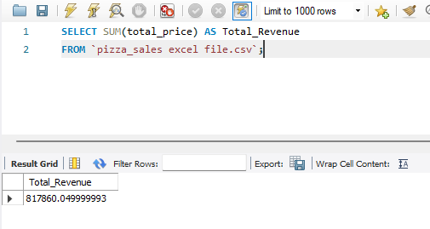

2.Average Order Value : The average amount spent per order, calculated by dividing the total revenue by the total number of orders.

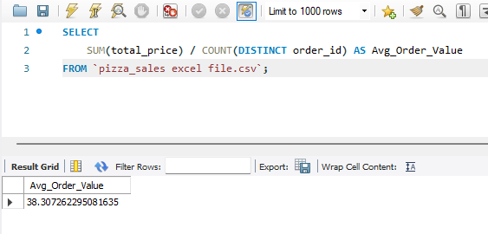

3.Total Pizzas Sold : The sum of the quantities of all pizzas sold.

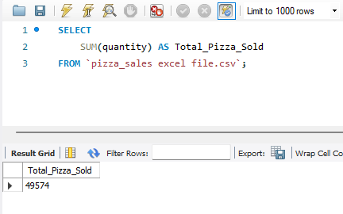

4.Total Orders : The total number of orders placed.

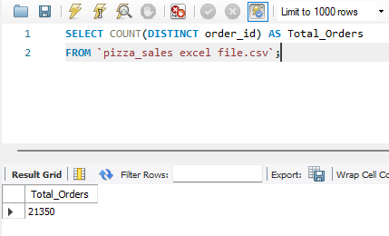

5.Average Pizzas Per Order : The average number of pizzas sold per order, calculated by dividing the total number of pizzas sold by the total number of orders.

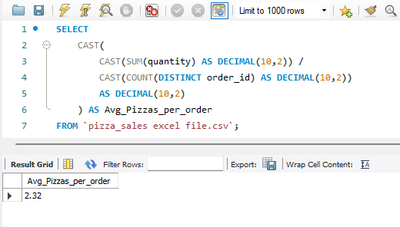

B.CHARTS REQUIREMENT

1.Daily Trend for Total Orders :

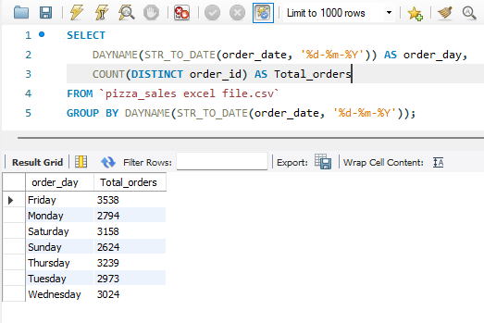

2.Hourly Trend for Total Orders :

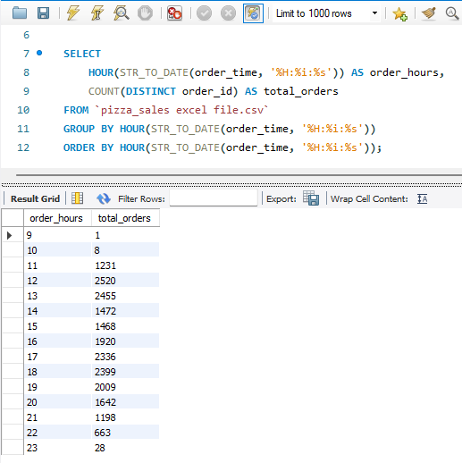

3.Percentage of sales by Pizza Category :
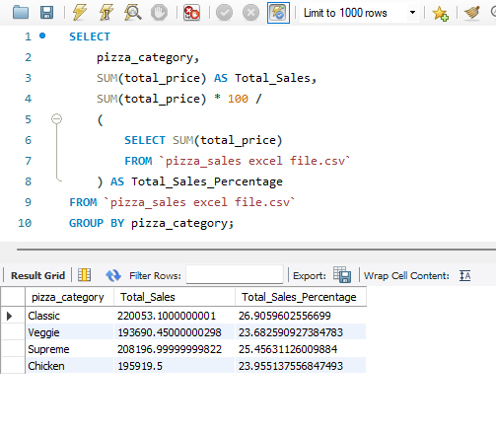

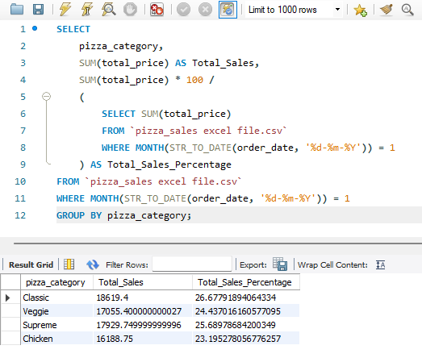
- Here MONTH(STR_TO_DATE(order_date, '%d-%m-%Y')) = 1 indicates that the output is for the month of January . MONTH(STR_TO_DATE(order_date, '%d-%m-%Y')) = 4 indicates output for month of April

4. Percentage of Sales by pizza size :

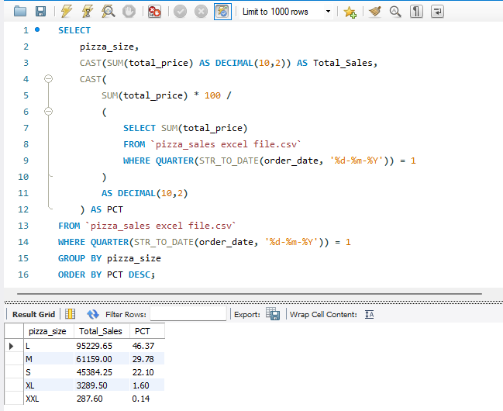

5. Total Pizzas Sold by Pizza Category :

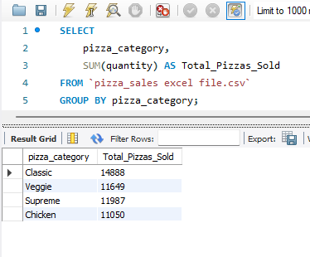
6.Top 5 Best Sellers by Total Pizzas Sold :

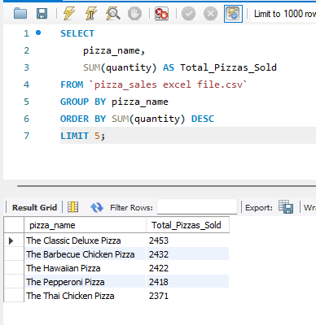

7.Bottom 5 Worst Sellers by Total pizzas Sold :

